No Limits Garage Party Entertainment Schedule
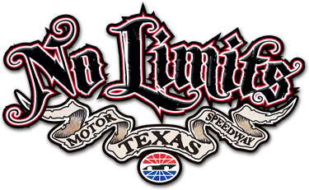
TIME | OVERALL ENTERTAINMENT TIMELINE
1:00pm | Gate 6 opens
1:00PM - 6:00PM | Concessions Open
1:00PM - 2:00PM | HAPPY HOUR - Levy Concessions
1:00PM - 6:00PM | Souvenir Stands Open
1:00PM - 6:00PM | Dale Earnhardt Display Open
1:00PM - 6:00PM | Euro Bungee Open
1:00PM - 6:00PM | No Limits Display Open
1:00PM - 6:00PM | Coke Zero Sponsor Display Open
1:00PM - 6:00PM | WinStar World Casino Sponsor Display Open
1:00PM - 6:00PM | GameStop Gaming Trailer Open
1:00PM - 5:30PM | Flip Book Station Open
1:00PM - 5:30PM | Spray Paint/Chalk Artist Gallery Open
1:00PM - 5:30PM | Airbrush Tattoo Parlor Open
1:00PM - 4:30PM | Disco Stilt Walkers with Afros Roaming
1:30PM - 5:30PM | Pig Races
2:00PM | REMAINING FRONTSTRETCH GATES OPEN
2:00PM - 6:00PM | Roller Derby Bouts
2:00PM - 5:30PM | Gold Dancers On Skates Roaming
2:00PM - 5:30PM | Stationary Disco Dancers
2:00PM - 5:30PM | Interactive Saturday Night Fever Dancers
TIME | STAGE TIMELINE
1:00PM - 2:00PM | DJ Live on Stage
2:00PM - 3:00PM | 1st Set from LeFreak
3:00PM - 4:30PM | Driver & VIP Q & A - Newy Scruggs Hosting, Sybil as MC  Giveaways with Newy and Sybil in between interviews
4:30PM - 5:30PM | 2nd Set from LeFreak
5:30PM - 6:00PM | DJ Live on Stage
ALL TIMES ARE SUBJECT TO CHANGE

